# Lab: CSS In Depth

Problems for exercises and homework for the “HTML and CSS” course @ SoftUni. Submit your solutions in the SoftUni judge system at <https://judge.softuni.bg/Contests/404/Lab-CSS-Selectors-and-Rules>.

## Coffee Home

Create a Web Page like the following using the HTML from the file "**coffee-home.html**". Write the missing CSS.

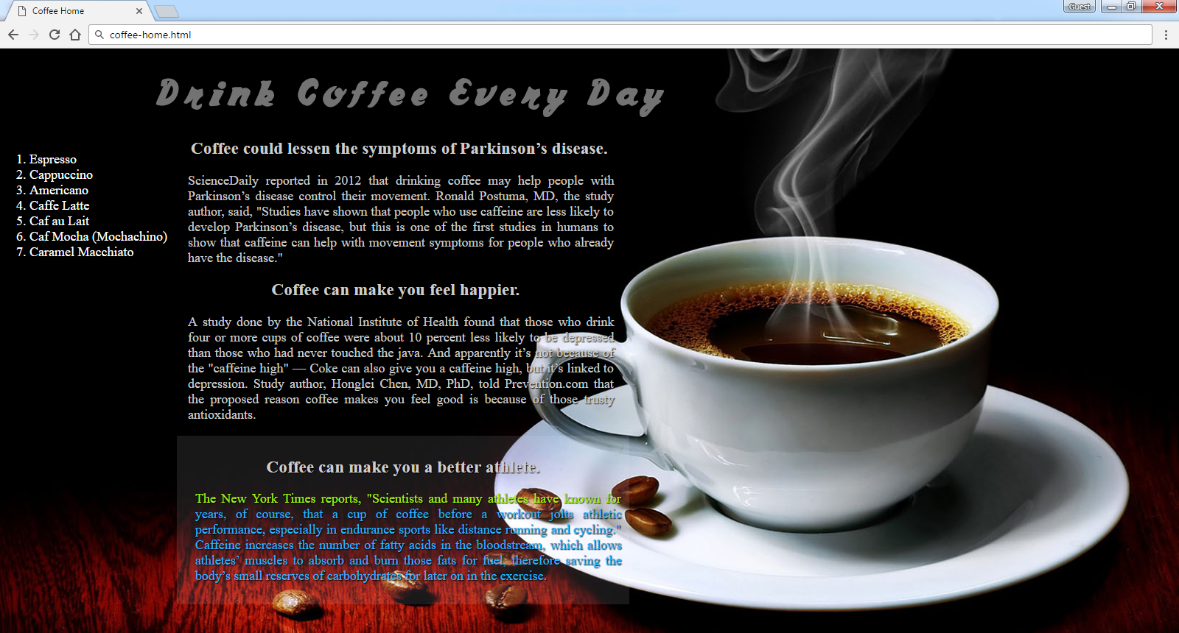

Create file: "**coffee-home.css**"

You are **NOT** allowed to change the HTML file.

Default font: **"Times New Roman", serif**

Default color: **#ffffff**

Font: **coffee**

Colors: **#737373, #CCCCCC, #22b6fd, #a6f016**

### Constrains

* Default font-size: **18px**

### Hints

Use:

* Define the “font-size” using rem